Total Score
_______ / 50 points
A  [Track 10] Listen to the conversation between Jake and his wife, Rebecca, about their friends Anne and Rob. Write T (true) or F (false).
1. Anne and Rob have been married for more than five years. ____
2. Rob wants to have children, but Anne doesn’t. ____
3. Anne and Rob used to talk about their problems. ____
4. In Jake’s opinion, Rob’s situation at work may be the cause of their
friends’ problems. ____
5. Jake thinks Anne should break up with Rob. ____
A _______ / 10 points (2 points each)
B Complete the sentences with the correct verbs from the box.
apologize | argue | communicate | compromise | forgive | lie
1. Her children never agree. They _____________________ about everything.
2. You said some embarrassing things to her yesterday. If you’re sorry,
you should _____________________.
3. He’s the most honest person I know. He doesn’t _____________________
about anything.
4. I lost your MP3 player. I’m really very sorry. Can you
_____________________ me?
5. Let’s _____________________. I’ll cook dinner if you wash the dishes.
6. If you’re unhappy with anything I’ve done, let’s talk about it. It’s important
to _____________________ openly.
B _______ / 6 points (1 point each)
C Circle the correct phrasal verb to complete each sentence.
1. I’d love to show you my new apartment. You should get together / drop by sometime.
2. I went for a walk in the park this morning, and guess who I ran into / took after.
3. If you need help with the party, you can count on / pick on me. Just call me!
4. I haven’t seen Larry in six months, but we’re getting together / getting along tonight.
5. If they can’t break up / get along, they probably shouldn’t get married.
6. He’s so immature! When is he going to take after / grow up?
C _______ / 6 points (1 point each)

D Write sentences with It’s . . . expressions and infinitives and the words in parentheses.
1. (helpful / speak / more than one language)
________________________________________________________
2. (not good / gossip / about your friends)
________________________________________________________
3. (never / a good idea / judge people)
________________________________________________________
4. (important / be / honest with your friends)
________________________________________________________
5. (not nice / say one thing and do another)
________________________________________________________
D _______ / 5 points (1 point each)
E Circle the correct answer to complete each sentence.
1. Jill might / must / can’t be angry at Tom. They’re going to a movie tonight.
2. I can’t find my cell phone. It might / must / couldn’t be at the office, but I’m
not sure.
3. He may not / must not / could come to soccer practice today because
he had a headache this morning. Can you call him to find out?
4. She might / must not / could speak English. She didn’t understand anything
you said.
5. I haven’t seen him this week. He couldn’t / must / could be on vacation,
but I’m not sure. He usually tells me when he’s going away.
6. I found a math book in my car. You’re the only math student I know,
so it may not / can’t / must be yours.
E _______ / 6 points (1 point each)
F Number the lines of the conversation in the correct order.
____ B: Thanks for understanding. Again, my apologies.
____ B: Yes. Why do you ask?
____ B: Oh, no! I was working late, and I completely forgot! I’m really sorry.
____ A: Hi, Terry. Is everything OK?
1
____ A: Well, we waited for you outside the movie theater last night,
but you never came.
____ A: There’s no need to apologize. I’m just glad you’re OK.
We were worried.
F _______ / 5 points (1 point each)

G Read the emails. Write T (true) or F (false).
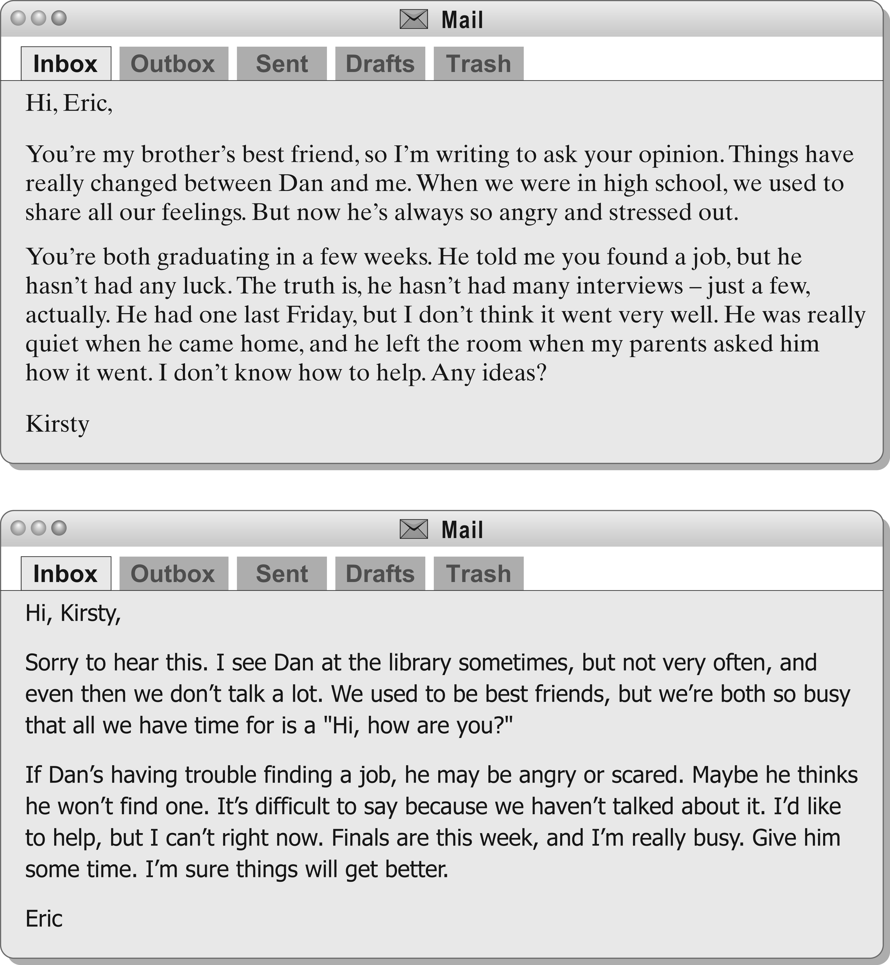
1. Dan and Kirsty used to have a good relationship. ____
2. Kirsty is criticizing her brother because he hasn’t found a job. ____
3. Dan has only had one job interview. ____
4. Eric’s relationship with Dan is not as good as it used to be. ____
5. Eric didn’t know about Dan’s problems. ____
6. Eric sometimes runs into Dan. ____
G _______ / 12 points (2 points each)

